|  |  |  |  |
| --- | --- | --- | --- |
| **Course Name:** | **Digital Design Laboratory** | **Semester:** | **III** |
| **Date of Performance:** | **___ / ___ / ______** | **Batch No:** | **C1** |
| **Faculty Name:** |  | **Roll No:** | **16010122245** |
| **Faculty Sign & Date:** |  | **Grade/Marks:** | **___/25** |

**Experiment No: 2**

**Title: Binary Adders and Subtractors**

|  |
| --- |
| **Aim and Objective of the Experiment:** |
| To implement half and full adder–subtractor using gates and IC 7483 |

|  |
| --- |
| **COs to be achieved:** |
| **CO2**: Use different minimization technique and solve combinational circuits. |

|  |
| --- |
| **Tools used:** |
| Trainer kits |

|  |
| --- |
| **Theory:** |
| **Adder:** The addition of two binary digits is the most basic operation performed by the digital computer. There are two types of adder:   * Half adder * Full adder   **Half Adder:** Half adder is a combinational logic circuit with two inputs and two outputs. It is the basic building block for the addition of two single-bit numbers.  **Full adder:** A half adder has a provision not to add a carry coming from the lower order bits when multi-bit addition is performed. for this purpose, a third input terminal is added and this circuit is to add A, B, and C where A and B are the nth order bits of the number A and B respectively and C is the carry generated from the addition of (n-1) order bits. This circuit is referred to as full adder.  **Subtractor:** Subtraction of two binary digits is one of the most basic operations performed by digital computer .there are two types of subtractors:   * Half subtractor * Full subtractor   **Half subtractor:** Logic circuit for the subtraction of B from A where A,B are 1 bit numbers is referred to as half subtract or .the subtract or process has two input and difference and borrow are the two outputs.  **Full subtractor:** As in the case of the addition using logic gates, a full subtractor is made by combining two half-sub tractors and an additional OR-gate. A full subtractor has the borrow in capability (denoted as BORIN) and so allows cascading which results in the possibility of multi-bit subtraction.  **IC 7483**  For subtraction of one binary number from another, we do so by adding 2’s complement of the former to the latter number using a full adder circuit.  IC 7483 is a 16 pin, 4-bit full adder. This IC has a provision to add the carry output to transfer and end around carry output using Co and C4 respectively.  **2’s complement:** 2’s complement of any binary no. can be obtained by adding 1 in 1’scomplement of that no.  e.g. 2’s complement of +(10)10 =1010is   |  |  |  |  | | --- | --- | --- | --- | | 1C of 1010 |  | | 0101 | |  |  | + | 1 | | -(10)10 |  | | 0110 |   In 2’s complement subtraction using IC 7483, we are representing negative number in 2’s complement form and then adding it with 1st number.  **Implementation Details:**  **Half Adder Block Diagram**    **Half Adder Circuit**    **Truth Table for Half Adder**   |  |  |  |  | | --- | --- | --- | --- | | **Inputs** | | **Outputs** | | | **A** | **B** | **A** | **B** | | 0 | 0 | 0 | 0 | | 0 | 1 | 1 | 0 | | 1 | 0 | 1 | 0 | | 1 | 1 | 0 | 1 |   **From the truth table (with steps):**  *0+0=0 no carry*  *0+1=1 no carry*  *1+0=1 no carry*  *1+1= 2 = 1 0 = 1 carry, sum 0*  *sum = A xor B*  *Carry = A and B*  **Full Adder Block Diagram**    **Full Adder Circuit**    **Truth Table for Full Adder**    **From the truth table (with steps):**  *0+0+0 = 0*  *0+0+1 = 1*  *0+1+1 = 2 = 1 carry + 0 sum*  *0+1+0 = 1*  *1+1+0 = 2 1 carry + 0 sum*  *1+1+1 = 3 1 carry + 1 sum*  *1+0+0 = 1*  *1+0+1 = 2 1 carry + 0 sum*  *Sum = A’ B’ C-IN + A’ B C-IN’ + A B’ C-IN’ + A B C-IN*  *C-out = A’ B C-IN + A B’ C-IN + A B C-IN’ + A B C-IN*    **Half Subtractor Block Diagram**    **Half Subtractor Circuit**    **Truth Table for Half Subtractor**   |  |  |  |  |  | | --- | --- | --- | --- | --- | |  |  |  |  |  | | **A** | **B** | **DIFFERENCE(D)** | **BORROW(Bo)** |  | |  |  |  |  |  | | 1 | 0 | 1 | 0 |  | |  |  |  |  |  | | 1 | 1 | 0 | 0 |  | |  |  |  |  |  | | 0 | 0 | 0 | 0 |  | |  |  |  |  |  | | 0 | 1 | 0 | 1 |  | |  |  |  |  |  |   **From the truth table (with steps) :**  *1-0=1*  *1-1=0*  *0-0=0*  *0-1 not possible so borrow =1 and difference=1*  *Diff= A’B+AB’*  *Borrow = A’B*  **Full Subtractor Block Diagram**    **Full Subtractor Circuit**    **Truth Table for Full subtractor**   |  |  |  |  |  | | --- | --- | --- | --- | --- | | **A** | **B** | **BIN** | **D** | **BOROUT** | |  |  |  |  |  | | 0 | 0 | 0 | 0 | 0 | |  |  |  |  |  | | 0 | 0 | 1 | 1 | 1 | |  |  |  |  |  | | 0 | 1 | 0 | 1 | 1 | |  |  |  |  |  | | 0 | 1 | 1 | 0 | 1 | |  |  |  |  |  | | 1 | 0 | 0 | 1 | 0 | |  |  |  |  |  | | 1 | 0 | 1 | 0 | 0 | |  |  |  |  |  | | 1 | 1 | 0 | 0 | 0 | |  |  |  |  |  | | 1 | 1 | 1 | 1 | 1 | |  |  |  |  |  |   **From the truth table (with steps):**  *bout = A’Bin + A’B + BBin*  *diff = Bin(A’B’ + AB) + Bin’(AB’ + A’B)*  *IC 7483*  *Procedure:*  *1) Locate the IC 7483 and 4-not gates block on trainer kit.*  *2) Connect 1st input no. to A4-A1 input slot and 2nd (negative) no. to B4-B1*  *through 4-not gates (1C of 2nd no.)*  *3) Connect high input to Co so that it will get added with 1C of 2nd no. to get 2C.*  *4) Connect 4-bit output to the output indicators.*  *5) Switch ON the power supply and monitor the output for various input*  **Example:**   |  |  |  | | --- | --- | --- | | 1) 710 -210 = 510 | |  | | 7 |  | 0111 | | 2 |  | 0010 | | 1’C of 2 | | 1101 | |  |  | + 1 | | 2’C of 2 | | 1110 |   0111 + 1110 1 0101  **Pin Diagram IC7483**  **Adder**    **Subtractor** |

|  |
| --- |
| **Implementation Details** |
| **Procedure:**   1. Locate the IC 7483 and 4-not gates block on trainer kit. 2. Connect 1st input no. to A4-A1 input slot and 2nd (negative) no. to B4-B1 through 4-not gates (1C of 2nd no.) 3. Connect high input to Co so that it will get added with 1C of 2nd no. to get 2C. 4. Connect 4-bit output to the output indicators. 5. Switch ON the power supply and monitor the output for various input combinations. |
| **Post Lab Subjective/Objective type Questions:** |
| 1. Design a full adder using two half adders. 2. Perform the following Binary subtraction with the help of appropriate ICs:    1. 6-4    2. 5-8    3. 7-9 |

**Ans 1:** The logic diagram of the full adder using two half adders is shown in Figure-3:

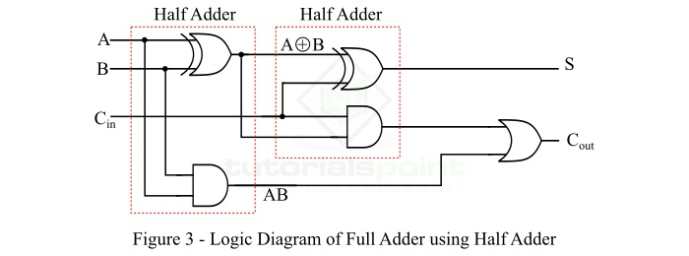

The block diagram of a full adder using two half adders is shown in Figure-4.

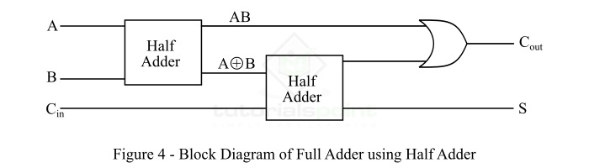

**Ans 2:** a. 6 - 4: Step 1: Convert the decimal numbers to binary. 6 (decimal) = 0110 (binary) 4 (decimal) = 0100 (binary)

Step 2: Perform binary subtraction. 0110 (6)

* 0100 (4)

So, 6 - 4 in binary is 0010.

b. 5 - 8: Step 1: Convert the decimal numbers to binary. 5 (decimal) = 0101 (binary) 8 (decimal) = 1000 (binary)

Step 2: Perform binary subtraction. 0101 (5)

* 1000 (8)

c. 7 - 9: Step 1: Convert the decimal numbers to binary. 7 (decimal) = 0111 (binary) 9 (decimal) = 1001 (binary)

Step 2: Perform binary subtraction. 0111 (7)

* 1001 (9)

|  |
| --- |
| **Conclusion:** |
| *Thus we have understood the working behind half adder, full adder , half subtracter and*  *full subtractor. We understood how the logic was implemented and how the operations worked with principals* |

|  |
| --- |
| **Signature of faculty in-charge with Date:** |